The following figures depict the fault trees representing the top event low water level in tank. The trees relating to APU1 are shown (the trees are symmetrical for APU2). The fault trees are mainly built for demonstration purposes and, thus, they do not necessarily represent a proper way to model such systems. However, the goal was to follow modelling conventions presented in [1] as much as possible. For the modelling and analysis of the fault trees FinPSA software [2] was used.

[1] Authén, S., Holmberg, J.-E., Tyrväinen, T., Zamani, L. 2015. Guidelines for reliability analysis of digital systems in PSA context - Final Report, NKS-330, Nordic nuclear safety research (NKS), Roskilde.

[2] FinPSA – tool for professional living PSA. 2016. <https://www.simulationstore.com/finpsa>

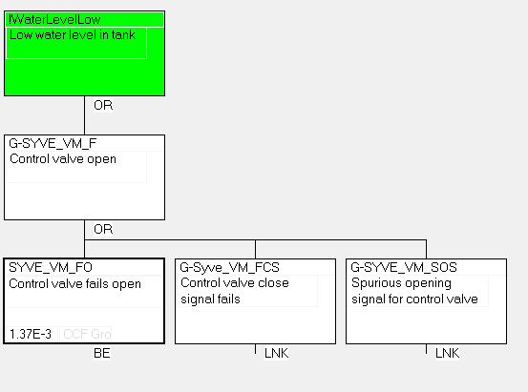

Figure 1. Master fault tree

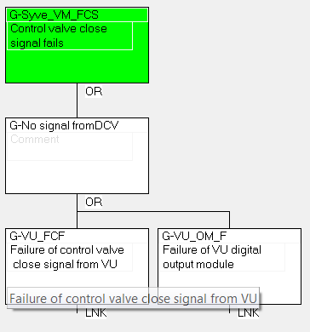

Figure 2. Control valve close signal fails.

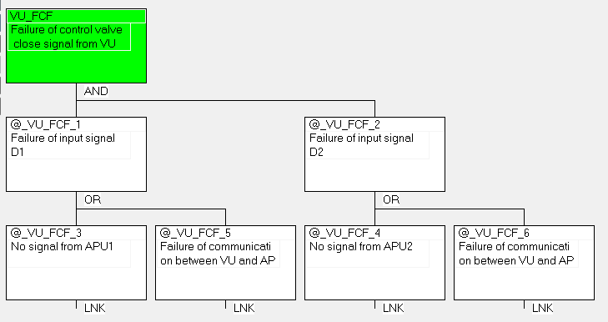

Figure 3. Failure of control valve close signal from Voting unit.

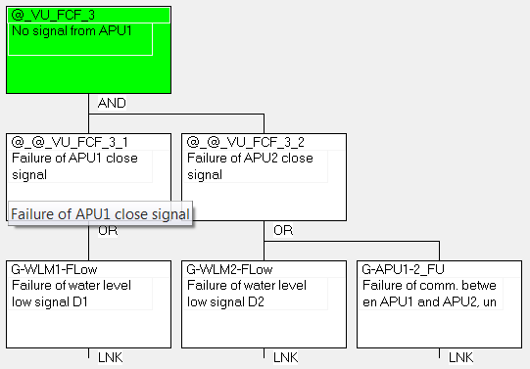

Figure 4. No close signal from APU1

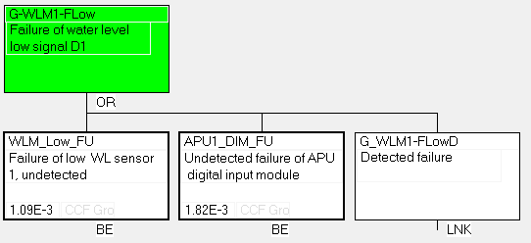

Figure 5. Failure of water level low signal (APU1).

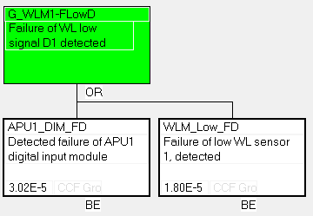

Figure 6. Failure of water level low signal (APU1), detected.

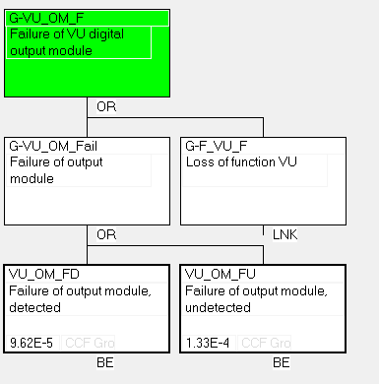

Figure 7. Failure of VU output module.

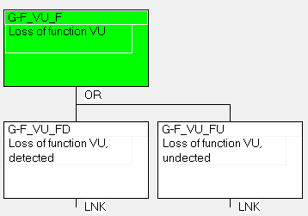

Figure 8. Loss of VU function.

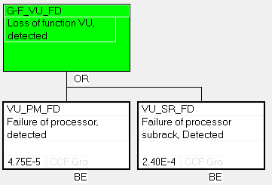

Figure 9. Loss of function VU, detected.

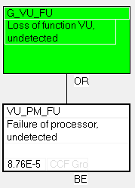

Figure 10. Loss of function, undetected.

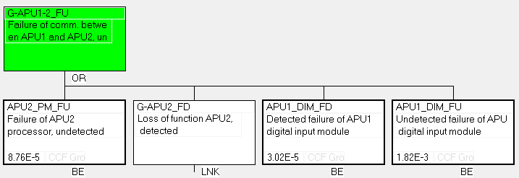

Figure 11. Failure of communication between APU1 and APU2.

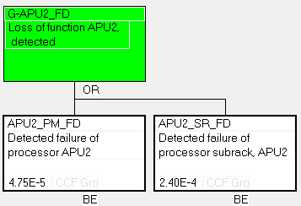

Figure 12. Loss of function APU2, detected.

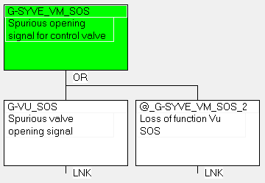

Figure 13. Spurious opening control valve opening signal.

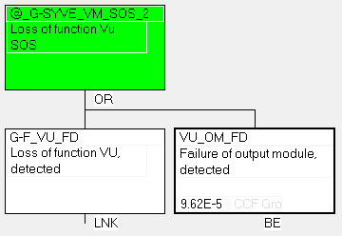

Figure 14. Loss of function VU, detected.

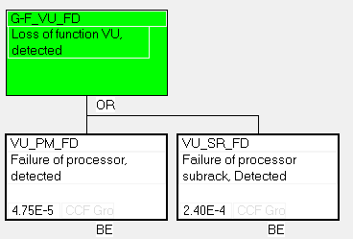

Figure 15. Detected loss of VU.

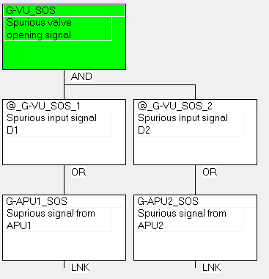

Figure 16. Spurious valve opening signal from APUs.

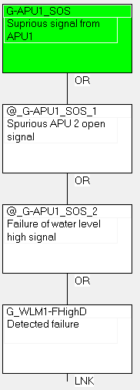

Figure 17. Spurious signal from APU1.

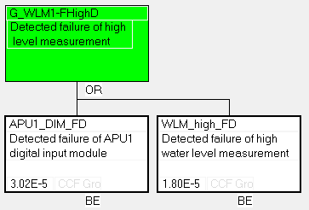

Figure 18. Detected failure of high level measurement.